1. to open a Visual Studio Code application, you need to open the search panel in the bottom left corner of the window screen then type in Visual Studio Code and press it then push open
2. then in Visual Studio Code press the extensions widget then type in the search Code Runner then push install
   1. To run Code Runner, use the shortcut Ctrl+Alt+N or press F1 and then type Run Code to run your code
   2. To stop Code Runner, use the shortcut Ctrl+Alt+M or press F1 and then type Stop Code Run to stop your code
   3. To select a certain coding language, use the shortcut Ctrl+Alt+J or press F1 then type Run by Language then select or type the language you want to run
3. You can also highlight certain code so you can run just that code as shown in the example

# Example:

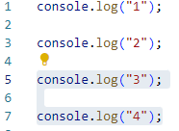

1. To run custom commands, use the shortcut Ctrl+Alt+K or press F1 and then type Run Custom Command
   1. 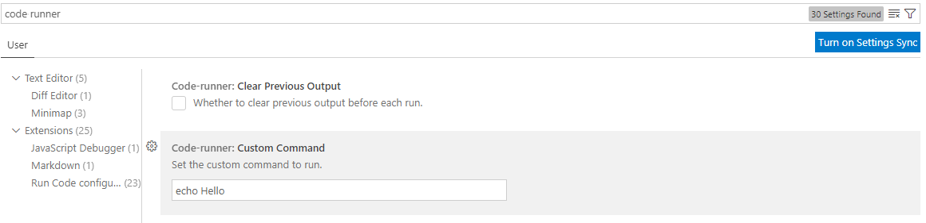To change the custom commands for Visual Studio Code, go into settings then type in Code Runner to change the custom command
2. to open a Visual Studio Code application, you need to open the search panel in the bottom left corner of the window screen then type in Visual Studio Code and press it then push open
3. then in Visual Studio Code press the extensions widget then type in the search Thunder Client then push install
   1. to start Thunder Client, go to where your extensions are and click the lighting bolt as shown in the example

# Example:

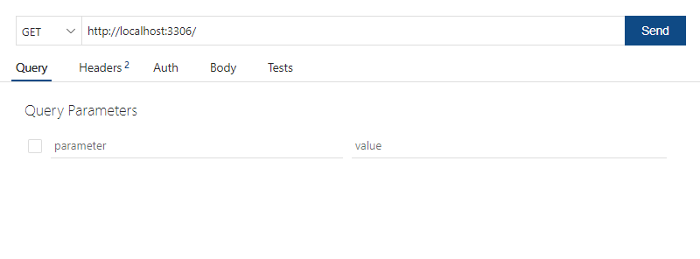

1. to start a new url get click new request as shown in the example
2. then you need to start a website in your Virtual Code with a app.js
   1. once started insert your url into the url box next to the GET
3. you then can add parameters to your url to see if everything is in order as well as being able to change your value for the url
4. to open a Visual Studio Code application, you need to open the search panel in the bottom left corner of the window screen then type in Visual Studio Code and press it then push open
5. then in Visual Studio Code press the extensions widget then type in the Bookmarks GitHub Repositories then push install
6. this allows you to place a bookmark in your code so you can come back to certain part of your code
   1. to add a bookmark to your code, open the bookmark next to extensions

then click bookmarks toggle

# Example:

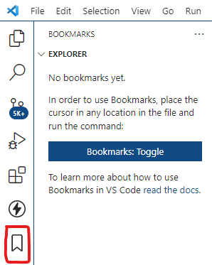

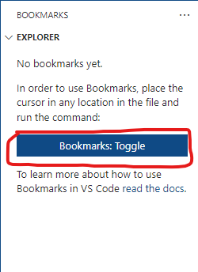

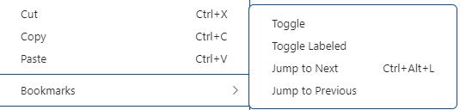

1. to jump to made bookmarks right click on any line of code then push jump to bookmark
2. to remove bookmark right click any code line then click toggle on the line of code with the bookmark